Sample Schemas

Container Tracking Schemas
The Normalized relational form of the container tracking schema is shown in Figure A.1.

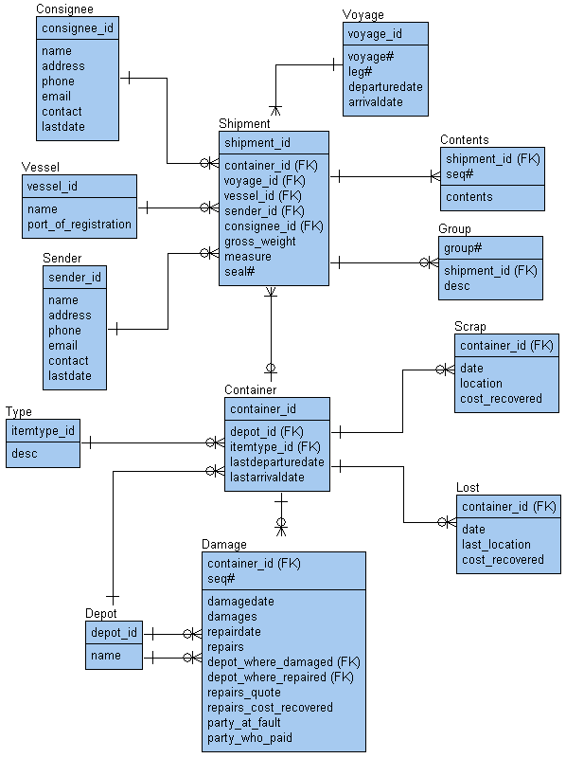
Figure A.1: The relational model container tracking schema
The dimensional-fact form of the container tracking schema is shown in Figure A.2 and Figure A.3. Figure A.2 shows facts for voyages of containers and Figure A.3 shows damage sustained to containers. In both Figure A2 and Figure A.3, fact tables are shaded and dimension tables are not.

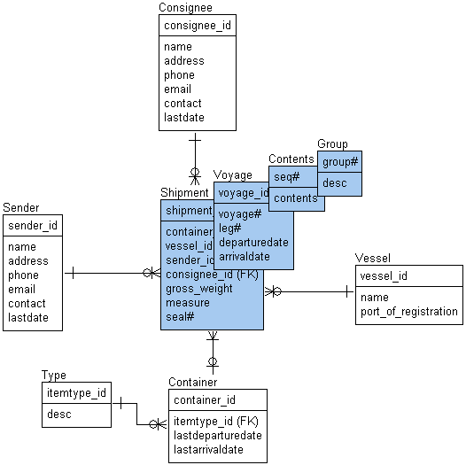
Figure A.2: Container voyages dimensional-fact tracking schema
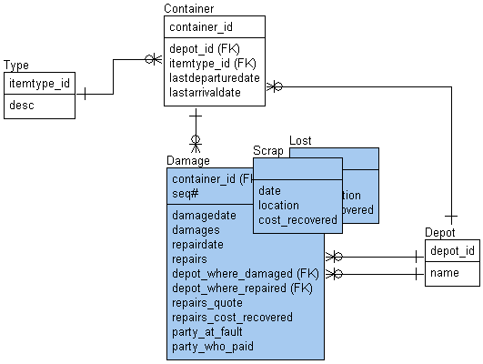
Figure A.3: Container damage dimensional-fact tracking schema

Demographics Schema
Two demographics schemas were used in this book, the first is shown in Figure A.4. The second version shown in Figure A.5 is a slightly enhanced version containing population and foreign exchange information.

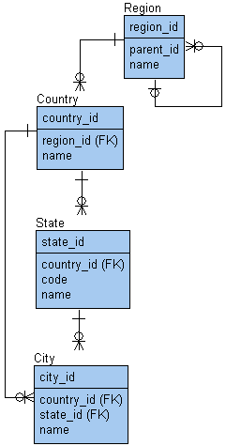
Figure A.4: Demographics for the locations dimension
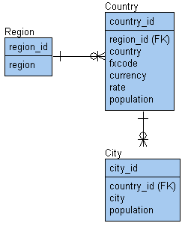
Figure A.5: Enhanced demographics

Inventory-Accounting Schema
The schema in Figure A.6 represents the original Normalized version of the OLTP database schema from which the data warehouse schema was created. The data warehouse schema is shown in Figure A.7.

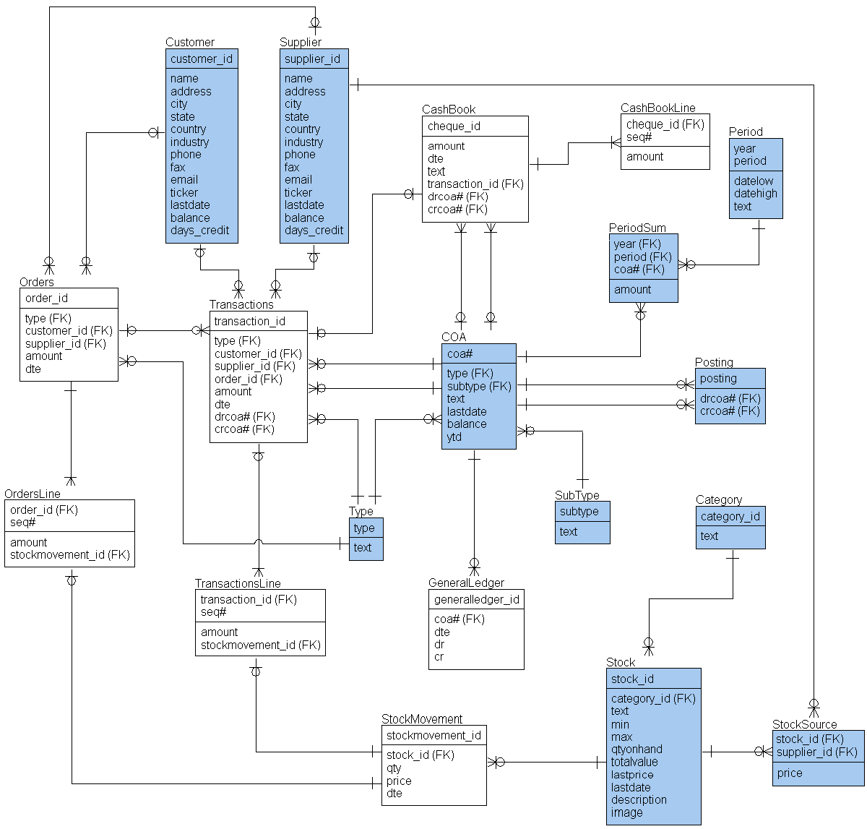
Figure A.6: OLTP transactional Normalized schema

Data Warehouse Schema
Figure A.7 shows the data warehouse schema, containing two fact table star schemas.

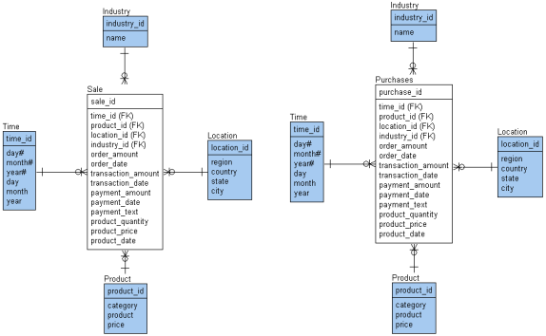
Figure A.7: The sales and purchases data warehouse schema

